Avyukta Journal of Management and Social Sciences
Vol. 10, No. 1, 2025 | www.aijmss.com

Integrating Big Data Analytics and Artificial Intelligence for Enterprise Financial Risk Management
Dr. Anirudh Kulkarni¹ and Dr. Shalini Bhatnagar²
¹ Independent Scholar, Chartered Accountant, Rohini, New Delhi, India
² Independent Scholar, Chartered Accountant, Rohini, New Delhi, India
Abstract
Enterprises face financial risks that are more numerous, more connected and faster-moving than ever before. At the same time, the volume of data available to measure those risks has grown enormously. IDC estimated that the global datasphere would expand from 33 zettabytes in 2018 to 175 zettabytes by 2025. Big data analytics provides the infrastructure to collect, store and process this information. Artificial intelligence (AI), particularly machine learning and natural language processing, provides the methods to extract predictive signals from it. This article examines how the two can be integrated to strengthen enterprise financial risk management. It reviews the concepts of enterprise risk management, big data and AI, and maps their applications across credit, market, liquidity, operational, cyber, fraud and compliance risk. It proposes a five-layer framework that links data sources, a data platform, AI analytics, risk decisions and governance. A simulation using 60,000 synthetic firm-quarters illustrates two central points. First, adding transaction data and text-based signals to financial ratios raised the accuracy of a financial distress early-warning model substantially: the area under the ROC curve rose from 0.745 to 0.827, and the share of distressed firms caught among the riskiest 10 percent rose from about 34 percent to 53 percent. Second, the more flexible model outperformed logistic regression only when the training sample exceeded about 20,000 observations, showing that big data and AI are complements. The article discusses evidence on adoption, the Indian context, including the Account Aggregator framework and the Digital Personal Data Protection Act, 2023, and the challenges of data quality, privacy, explainability and skills. It concludes with a practical roadmap for implementation.
Keywords: big data analytics, artificial intelligence, enterprise risk management, machine learning, early-warning systems, financial risk, India
Cite this article: Kulkarni, A., & Bhatnagar, S. (2025). Integrating big data analytics and artificial intelligence for enterprise financial risk management. Avyukta Journal of Management and Social Sciences, 10(1), 10–18.

1. Introduction
Financial risk management has always depended on information. Banks assess borrowers using their financial statements and repayment histories; treasurers monitor interest rates and exchange rates; auditors examine transactions for errors and fraud. For most of the twentieth century, however, the information available was limited, periodic and largely structured. Annual accounts arrived months after the period they described, and risk models were built on small samples of carefully selected variables.
This situation has changed dramatically. Digital payments, enterprise resource planning (ERP) systems, electronic invoicing, online news, regulatory filings and social media now generate continuous streams of data about firms, customers and markets. IDC estimated that the global datasphere, the total amount of data created, captured and replicated, would grow from 33 zettabytes in 2018 to 175 zettabytes by 2025, and that nearly 30 percent of data would be real-time by 2025, compared with 15 percent in 2017 (Reinsel et al., 2018). For risk managers, this abundance creates both an opportunity and a challenge. Much of the new data is relevant to risk, but it is too large, too fast and too varied to be analysed with traditional tools.
Two developments make it possible to exploit this data. Big data analytics provides the technology to collect, store, integrate and process large and diverse datasets, through distributed storage, cloud computing and streaming platforms. Artificial intelligence, particularly machine learning, provides methods that learn patterns from data, capture non-linear relationships and process unstructured information such as text. Each is of limited value without the other. Big data without AI produces storage costs without insight; AI without big data produces models that are fragile and narrow.
This article examines how big data analytics and AI can be integrated for enterprise financial risk management. It addresses four questions. What do big data and AI contribute to the management of different financial risks? How can they be combined in an integrated architecture? What evidence exists on their value? And what challenges must organisations, particularly in India, overcome to use them responsibly? Section 2 sets out the conceptual foundations. Section 3 maps applications across risk types. Section 4 proposes an integrated framework. Section 5 reviews evidence on adoption and value. Section 6 reports a simulation experiment. Section 7 discusses the Indian context, Section 8 the challenges, Section 9 a roadmap for implementation and Section 10 concludes.

2. Conceptual Foundations

2.1 Enterprise financial risk management
Enterprise risk management (ERM) is an approach that considers risks across the whole organisation rather than in separate silos. The Committee of Sponsoring Organizations of the Treadway Commission (COSO, 2017) describes it as the culture, capabilities and practices, integrated with strategy-setting and performance, that organisations rely on to manage risk in creating, preserving and realising value. Financial risks are central to ERM. They include credit risk, the risk that counterparties fail to pay; market risk, from movements in interest rates, exchange rates, commodity and equity prices; liquidity risk, the risk of being unable to meet obligations as they fall due; and operational risk, from failed processes, people, systems or external events, including fraud and cyberattacks.
The defining feature of ERM is integration. Risks interact: a sharp depreciation of the currency can raise the cost of foreign-currency debt, squeeze margins, weaken customers’ ability to pay and strain liquidity at the same time. Managing these connections requires data that can be brought together across functions and analysed as a whole. For banks, the Basel Committee’s principles for effective risk data aggregation and risk reporting (BCBS 239) emphasise this point, requiring that risk data be accurate, complete, timely and capable of being aggregated across the group (Basel Committee on Banking Supervision, 2013).

2.2 Big data
Big data is commonly characterised by the “Vs” summarised in Table 1 (Gandomi & Haider, 2015). Volume refers to the scale of data; velocity to the speed at which it is generated and must be processed; variety to the mix of structured, semi-structured and unstructured formats; veracity to uncertainty about quality and reliability; and value to the potential for useful insight. In financial risk management, each dimension has specific implications.

Table 1
Dimensions of big data and their implications for financial risk management
Dimension | Meaning | Example in financial risk management | Implication
Volume | Very large datasets | Millions of payment transactions per day | Distributed storage and computing
Velocity | Data generated and needed in real time | Market prices, card authorisations | Streaming analytics, low-latency models
Variety | Structured, semi-structured and unstructured data | Ledgers, invoices, news, filings, emails | Integration; text and graph analytics
Veracity | Uncertain quality and reliability | Missing values, errors, manipulated reviews | Data quality controls and validation
Value | Potential for actionable insight | Earlier warning of borrower distress | Clear business use cases and metrics
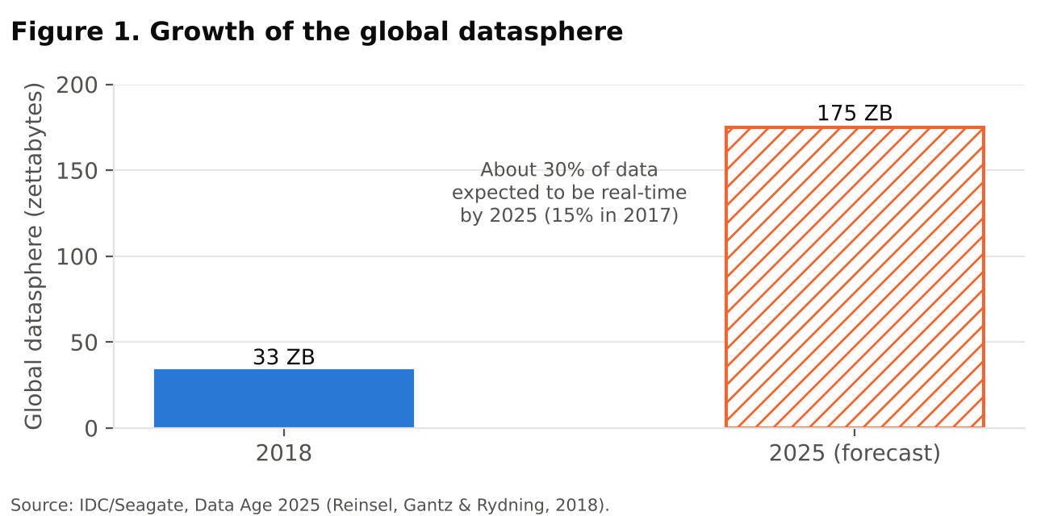

Figure 1 shows the scale of growth in the global datasphere. The shift towards real-time data is particularly significant for risk management, because many financial risks, such as fraud, market shocks and liquidity runs, develop in hours or minutes rather than quarters.

2.3 Artificial intelligence
Artificial intelligence refers broadly to computer systems that perform tasks normally requiring human intelligence. In risk management, the most important branch is machine learning, in which algorithms learn relationships from data rather than following explicitly programmed rules. Supervised methods, such as random forests (Breiman, 2001) and gradient boosting (Chen & Guestrin, 2016), learn to predict outcomes such as default or fraud from labelled examples. Unsupervised methods, such as clustering and anomaly detection, identify unusual patterns without labels. Natural language processing (NLP) converts text into measurable signals; for example, the tone of news articles and corporate filings has been shown to contain information about future returns and earnings (Tetlock, 2007; Loughran & McDonald, 2011). Graph analytics examines networks of relationships, such as connections between companies, directors, suppliers and accounts, which are central to detecting contagion and money laundering.
The Financial Stability Board (2017) noted early that AI and machine learning could improve the efficiency of risk management, regulatory compliance and fraud detection, while warning that their opacity, reliance on data and potential for concentration among a few providers could create new risks. These themes remain central.

3. Applications Across Financial Risk Types
The integration of big data and AI can support every major category of financial risk. Table 2 summarises the main data sources, techniques and outputs for each.

Table 2
Big data and AI applications by financial risk type
Risk type | Big data sources | AI techniques | Typical outputs
Credit risk | Financial statements, bank and GST flows, bureau data, payment behaviour | Gradient boosting, survival models | Default probabilities, early-warning alerts
Market risk | Tick data, order books, news, social media | Time-series ML, NLP sentiment | Volatility forecasts, scenario signals
Liquidity risk | Treasury and payment systems, deposit flows | Forecasting models, simulation | Cash-flow forecasts, liquidity alerts
Operational and cyber risk | System logs, incident records, access data | Anomaly detection, NLP on incident reports | Control failures, intrusion alerts
Fraud and compliance | Transactions, devices, customer networks | Supervised ML, graph analytics | Fraud scores, suspicious activity reports
Strategic and ESG risk | Supplier data, satellite data, news, disclosures | NLP, classification | Supply-chain and climate exposure

3.1 Credit risk
Credit risk models have traditionally relied on financial ratios. Altman’s (1968) Z-score combined five ratios in a discriminant model of corporate bankruptcy, and ratio-based logistic models remain common. Machine learning has improved on these models in many studies. Barboza et al. (2017) found that machine-learning methods such as random forests and boosting predicted corporate bankruptcy more accurately than traditional statistical methods. Khandani et al. (2010) found that machine-learning models of consumer credit risk, built on transaction-level data from a commercial bank, substantially improved forecasts of delinquency.
Big data adds new sources of information. Monthly bank-account flows, goods and services tax (GST) returns, invoices and supplier payment behaviour reveal changes in a firm’s condition long before they appear in annual accounts. Berg et al. (2020) showed that even simple digital footprint variables, such as the device and email provider used by an online customer, predicted default about as well as credit bureau scores, and that combining both improved accuracy.

3.2 Market and liquidity risk
Market risk management depends on understanding how prices move and how they might move under stress. High-frequency market data, combined with machine-learning forecasting models, can improve volatility estimates and identify regime changes. NLP applied to news and social media can provide early indications of shifts in sentiment. For liquidity risk, AI-based forecasting of cash inflows and outflows, using detailed payment and treasury data, can help corporate treasurers and banks anticipate shortfalls and optimise buffers.

3.3 Operational, cyber and fraud risk
Operational risk, including fraud and cyber risk, is perhaps where big data and AI are most visibly used. Fraud detection systems score millions of transactions in real time, combining transaction amounts, timing, location, device data and customer history. Graph analytics can uncover networks of mule accounts used in money laundering. Cybersecurity tools apply anomaly detection to system logs and network traffic.
The financial stakes are large. IBM’s Cost of a Data Breach Report 2024 found that the global average cost of a data breach reached USD 4.88 million, a 10 percent increase on the previous year. Organisations that used security AI and automation extensively incurred average costs about USD 2.2 million lower than those that did not (IBM, 2024). In India, the average cost of a breach reached ₹19.5 crore, about 9 percent higher than in 2023.

3.4 Strategic and ESG risk
Enterprises increasingly face risks from supply-chain disruptions, climate change and reputational damage. Big data sources such as supplier networks, shipping data, satellite imagery and news coverage, analysed with AI, can help firms identify exposure to disruptions or environmental and social controversies. These applications are still developing, but they extend financial risk management towards a more forward-looking and comprehensive view.

4. An Integrated Framework
Many organisations use big data and AI in isolated projects, such as a fraud model in one department and a sentiment tool in another. The full value comes from integration. Figure 2 presents a five-layer framework for integrating big data analytics and AI into enterprise financial risk management.

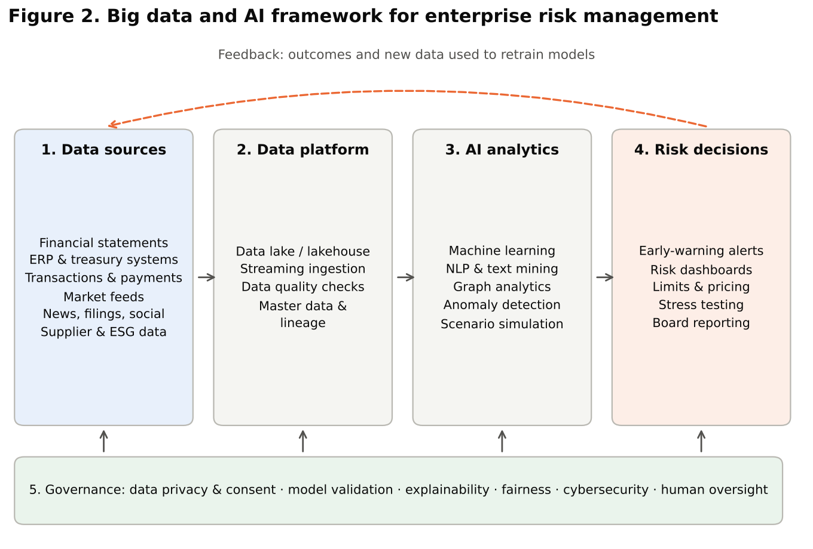

Layer 1: Data sources. The framework begins with internal data, such as financial statements, ERP and treasury systems and transaction records, and external data, such as market feeds, news, regulatory filings, supplier information and environmental, social and governance (ESG) data. The breadth of sources determines how complete a picture of risk the organisation can form.
Layer 2: Data platform. Data from different sources must be ingested, cleaned, standardised and stored so that it can be combined. Modern architectures use data lakes or “lakehouses” that hold structured and unstructured data together, with streaming ingestion for real-time data. Master data management ensures that a customer, supplier or counterparty is identified consistently across systems, and data lineage records where each data item came from and how it was transformed. These capabilities are essential to meet standards such as BCBS 239.
Layer 3: AI analytics. On top of the platform, analytical models generate risk signals. These include supervised machine-learning models for default or fraud prediction, NLP models that extract sentiment and events from text, graph models for network risk, anomaly detection for unknown threats and simulation models for stress testing.
Layer 4: Risk decisions. Model outputs are useful only if they change decisions. The decision layer translates signals into early-warning alerts, risk dashboards, credit limits, pricing, hedging actions, stress-test results and reports for senior management and the board. Clear thresholds, escalation routes and accountability are essential.
Layer 5: Governance. Governance spans all layers. It covers data privacy and consent, model validation, explainability, fairness, cybersecurity and human oversight. It ensures that the system is reliable, lawful and trusted.
A feedback loop connects the decision layer back to the data layer. Outcomes, such as whether flagged borrowers actually defaulted or whether alerts were genuine frauds, become new training data, allowing models to be updated as conditions change. This loop distinguishes a learning risk system from a static one.

5. Evidence on Adoption and Value
Research on big data analytics in business suggests that its value depends on organisational capabilities, not technology alone. Chen et al. (2012) traced the evolution of business intelligence and analytics towards big data, and Wamba et al. (2015) found in a systematic review that big data creates value through improved transparency, experimentation, segmentation, decision support and innovation, but only when organisations develop the capabilities to use it.
In financial services, estimates of potential value are substantial. McKinsey and Company (2020) estimated that AI technologies could deliver up to USD 1 trillion of additional value each year for global banking, through higher revenues, lower costs and better risk management. Adoption is advancing rapidly. A 2024 survey of financial firms by the Bank of England and the Financial Conduct Authority (2024) found that 75 percent were already using AI, up from 58 percent in 2022, with cybersecurity and fraud detection among the most common uses. Table 3 summarises selected global indicators.

Table 3
Selected global indicators on big data, AI and financial risk
Indicator | Value | Source
Global datasphere, 2018 | 33 zettabytes | IDC (Reinsel et al., 2018)
Global datasphere, 2025 (forecast) | 175 zettabytes | IDC (Reinsel et al., 2018)
Share of data that is real-time, 2025 (forecast) | nearly 30% | IDC (Reinsel et al., 2018)
Potential annual value of AI in global banking | up to USD 1 trillion | McKinsey and Company (2020)
UK financial firms using AI, 2024 (2022) | 75% (58%) | Bank of England and FCA (2024)
Global average cost of a data breach, 2024 | USD 4.88 million | IBM (2024)
Cost reduction with extensive security AI and automation | about USD 2.2 million | IBM (2024)

6. Simulation: Big Data, AI and Early Warning of Financial Distress

6.1 Design
To illustrate how big data and AI interact, we conducted a simulation of an early-warning system for corporate financial distress. Synthetic data were generated for 60,000 firm-quarters. The probability that a firm entered financial distress in the following period depended on three groups of variables, corresponding to successive layers of data that an enterprise or lender might use (Table 4).

Table 4
Design of the simulation
Data layer | Variables | Characteristics
1. Financial ratios | Leverage, interest coverage, return on assets, liquidity, size | Annual; observed with delay and measurement error
2. Transaction data | Cash-flow volatility, payment delays, revenue trend from bank and GST flows | Monthly; reflects current conditions
3. Text and external data | Tone of news and filings, supplier stress | Continuous; partly reflects unobserved shocks
Outcome | Financial distress in the next period | Base rate about 4.3%

The data-generating process included non-linear effects and interactions. For example, high leverage was particularly dangerous when combined with volatile cash flows, and long payment delays raised risk sharply for firms with weak liquidity. Distress also depended on an unobserved shock that financial statements did not capture but that was partly reflected in revenue trends and the tone of news. Two models were compared: logistic regression, representing the traditional approach, and gradient boosting, representing machine learning. Each model was trained on 70 percent of the data and evaluated on the remaining 30 percent. Accuracy was measured by the area under the ROC curve (AUC) and by the share of distressed firms captured among the 10 percent of firms with the highest predicted risk, a practical measure for an institution that can only review a limited number of cases. The results are illustrative and do not represent any real portfolio.

6.2 Results
Table 5 and Figure 3 report the results. Adding data layers produced the largest improvements. Using financial ratios alone, both models achieved an AUC of 0.745. Adding transaction data raised the AUC to 0.801 for logistic regression and 0.811 for gradient boosting. Adding text and external data raised it further, to 0.812 and 0.827 respectively.

Table 5
Simulation results (test sample of 18,000 firm-quarters)
Data used | Model | AUC | Brier score | Distressed firms in riskiest 10%
Financial ratios only | Logistic regression | 0.745 | 0.0391 | 33.3%
Financial ratios only | Gradient boosting | 0.745 | 0.0388 | 34.5%
Ratios + transaction data | Logistic regression | 0.801 | 0.0370 | 44.5%
Ratios + transaction data | Gradient boosting | 0.811 | 0.0360 | 48.7%
Ratios + transaction + text/external | Logistic regression | 0.812 | 0.0363 | 47.4%
Ratios + transaction + text/external | Gradient boosting | 0.827 | 0.0352 | 53.4%
Note. Authors’ calculation on synthetic data.
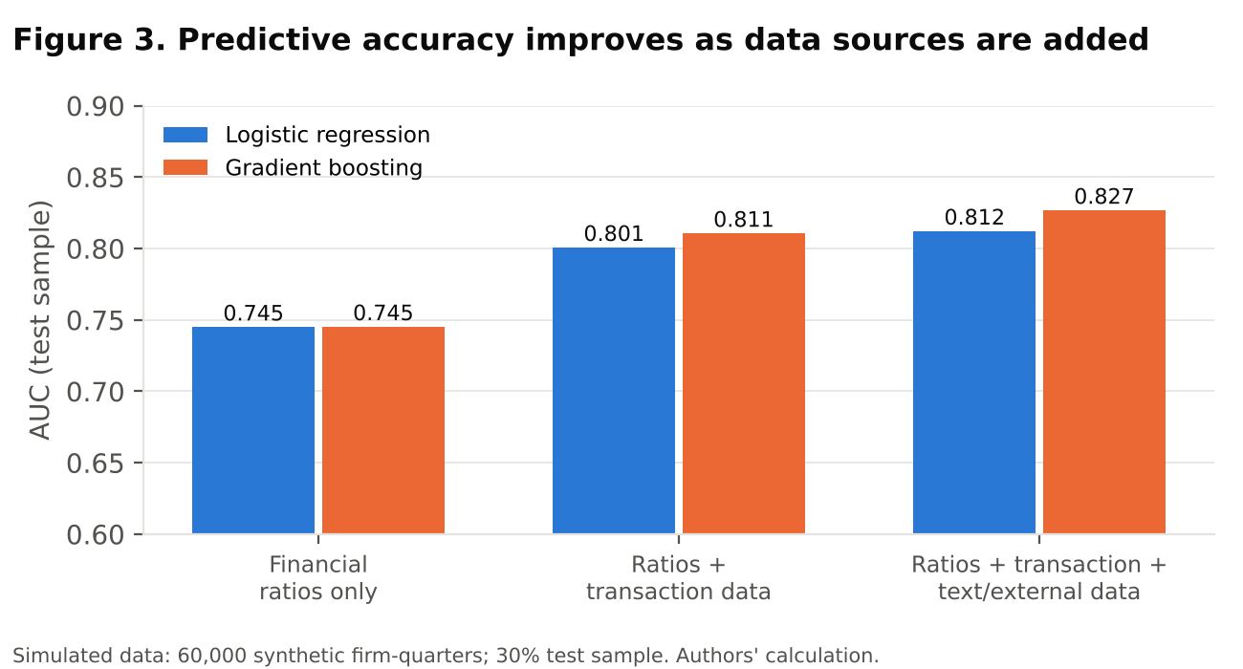

The practical significance is shown in Figure 4. When the riskiest 10 percent of firms were flagged for review, the model using only financial ratios caught about one-third of the firms that later became distressed. The gradient-boosting model using all three data layers caught 53.4 percent. In other words, with the same review capacity, the integrated system identified about 60 percent more troubled firms in advance. Lower Brier scores also indicate that the probabilities produced by the richer models were more accurate.

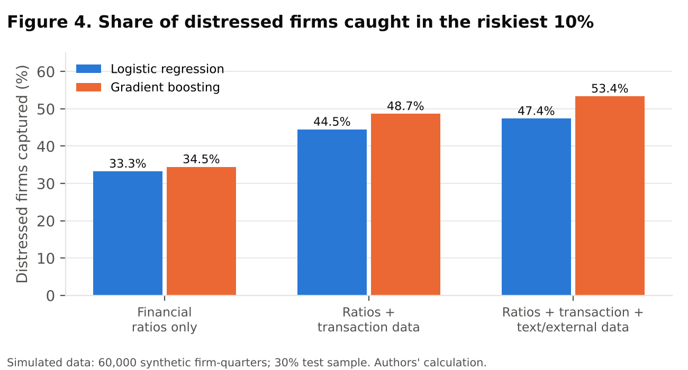

The advantage of machine learning over logistic regression grew as more data layers were added. With ratios alone, the two models were equivalent. With all layers, gradient boosting captured six percentage points more distressed firms. This is because the richer data contained interactions, for example between leverage and cash-flow volatility, which the flexible model could learn but the linear model could not.

6.3 Why big data and AI are complements
Figure 5 shows how model accuracy changed with the size of the training sample, using all three data layers. With 1,000 to 10,000 observations, logistic regression outperformed gradient boosting. The flexible model needs more data to learn complex patterns reliably without overfitting. Only when the training sample reached about 20,000 observations did gradient boosting overtake logistic regression, and its advantage persisted with 42,000 observations.

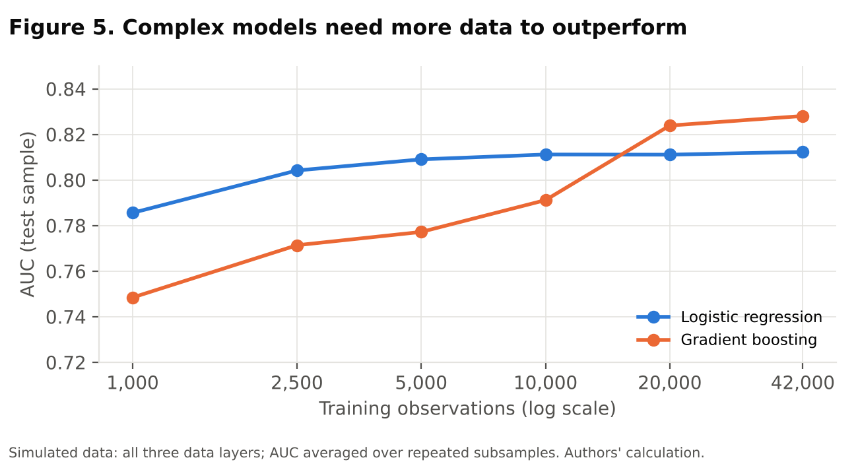

The simulation therefore illustrates three lessons. First, better data often matters more than better algorithms: the largest gains came from adding transaction and text data, not from changing the model. Second, AI adds value mainly when data are rich: flexible models outperform simple ones when there are enough observations and enough variables to reveal non-linear relationships. Third, big data and AI are complements: large datasets are needed to exploit AI, and AI is needed to exploit large and varied datasets. Organisations that invest in only one are unlikely to realise the full benefit.

7. The Indian Context
India offers a striking example of how digital infrastructure can generate data for risk management. Unified Payments Interface (UPI) transactions reached about 131 billion in 2023–24, compared with about 84 billion in 2022–23 (Business Today, 2024). The Account Aggregator framework, regulated by the Reserve Bank of India (RBI), allows individuals and businesses to share their financial data, such as bank statements, with regulated entities through consent. According to Sahamati, the industry alliance for the framework, 2.12 billion financial accounts were enabled on the framework in 2024, and loans worth ₹42,300 crore had been facilitated through it by March 2024. The framework crossed 100 million consents in August 2024 (Business Standard, 2024b). For lenders, consented access to transaction-level data makes cash-flow-based credit assessment possible for small businesses that lack collateral or detailed financial statements, exactly the kind of transaction layer that improved accuracy in the simulation.
The same digitisation has increased risks. According to the RBI’s Annual Report 2023–24, the number of frauds reported by banks rose from 13,564 in 2022–23 to 36,075 in 2023–24, although the amount involved fell from ₹26,127 crore to ₹13,930 crore (Business Standard, 2024a). The rise in many smaller digital frauds requires real-time, data-driven detection. Data breaches are also costly: IBM (2024) estimated the average cost of a breach in India at ₹19.5 crore. Table 6 summarises these indicators.

Table 6
Indicators of data availability and risk in India
Indicator | Value | Period | Source
UPI transactions | about 131 billion | 2023–24 | NPCI via Business Today
Financial accounts enabled on Account Aggregator | 2.12 billion | 2024 | Sahamati via Business Standard
Loans facilitated through Account Aggregator (cumulative) | ₹42,300 crore | to March 2024 | Sahamati via Business Standard
Account Aggregator consents | over 100 million | August 2024 | Sahamati via Business Standard
Frauds reported by banks (number) | 36,075 | 2023–24 | RBI Annual Report
Average cost of a data breach in India | ₹19.5 crore | 2024 | IBM

The regulatory environment is also evolving. The Digital Personal Data Protection Act, 2023, establishes requirements for consent, purpose limitation, data minimisation and the protection of personal data, which affect how enterprises collect and use data for risk models. The RBI’s guidelines on digital lending emphasise transparency and the protection of borrowers. Indian enterprises must therefore design their big data and AI systems to be compliant by design, not as an afterthought.

8. Challenges
Despite their potential, integrating big data analytics and AI into financial risk management involves significant challenges.
Data quality and integration. Risk models are only as good as their data. Enterprise data is often fragmented across legacy systems, inconsistent in definitions and incomplete. Unstructured data, such as news and social media, may be noisy or even manipulated. Investing in data quality, master data management and lineage is less glamorous than building models, but it is often the more important task.
Privacy and consent. The use of personal and transaction data raises privacy concerns. Organisations must ensure that they have a lawful basis for using data, that consent is meaningful and that data are protected against breaches. In India, compliance with the Digital Personal Data Protection Act, 2023, is essential.
Explainability. Complex models may be difficult to interpret. Yet risk decisions often require explanation to customers, auditors, regulators and boards. Methods such as Shapley additive explanations (SHAP) can attribute each prediction to the contribution of individual variables (Lundberg & Lee, 2017), but explanations should be validated and communicated carefully.
Fairness. Models trained on historical data can reproduce or amplify existing biases. Fuster et al. (2022) found that machine-learning credit models, while more accurate overall, could increase disparities in outcomes between groups. Organisations should test models for unjustified differences across groups and correct them.
Model risk. Models can fail because of errors in design, data or implementation, or because conditions change. Machine-learning models may be especially vulnerable to shifts in the data, such as those caused by economic shocks or changing fraud tactics. Independent validation, ongoing monitoring and clear limits on model use are necessary.
Cybersecurity and third-party dependence. Centralising large amounts of sensitive data creates an attractive target for attackers. Reliance on a few cloud and AI providers also creates concentration risk, a concern highlighted by the Financial Stability Board (2017).
Skills and culture. Effective integration requires people who understand both finance and data science, and a culture in which managers trust and question model outputs appropriately. Many organisations face shortages of such skills.
Cost and return. Big data platforms and AI systems require significant investment. Without clear use cases and measures of value, projects may fail to deliver. Starting with high-value applications and measuring their impact helps justify further investment.

9. A Roadmap for Implementation
Based on the framework and the challenges discussed, we propose a phased roadmap for enterprises seeking to integrate big data analytics and AI into financial risk management.
Phase 1: Foundations. Define the risk management objectives and the decisions that analytics should support. Map existing data sources across the enterprise and assess their quality. Establish data governance, including ownership, definitions, privacy controls and lineage. Build or adopt a data platform that can integrate structured and unstructured data.
Phase 2: Priority use cases. Select a small number of high-value applications, such as an early-warning system for credit risk or real-time fraud detection. Develop models with simple benchmarks, such as logistic regression, alongside more complex methods, and compare them using metrics that reflect business value, such as the share of losses captured at a given review capacity. Pilot the models alongside existing processes before full deployment.
Phase 3: Integration and scale. Connect individual models to an enterprise-wide view of risk through dashboards and reports. Link credit, market, liquidity and operational risk signals to identify interactions and concentrations. Incorporate AI-based scenarios into stress testing and capital planning.
Phase 4: Continuous improvement. Monitor model performance and data drift, retrain models regularly and incorporate feedback from outcomes. Review governance arrangements periodically as regulations and technologies evolve. Build skills across the organisation through training and cross-functional teams.
Throughout the roadmap, organisations should observe several principles. They should keep humans responsible for consequential decisions, ensuring that models support rather than replace judgement. They should document data, models and decisions to support accountability. They should measure results rigorously, comparing new systems with existing practice. And they should treat privacy, fairness and security as design requirements rather than compliance checklists.
For regulators and policymakers, the analysis suggests several priorities: promoting standards for data quality and interoperability, encouraging responsible data-sharing frameworks such as the Account Aggregator system, providing guidance on model risk management and explainability for AI, and supporting the development of skills in data science and risk management.

10. Conclusion
Big data analytics and artificial intelligence are transforming enterprise financial risk management. Big data expands the information available about firms, customers and markets, and makes it available in near real time. AI provides the methods to turn that information into predictions and early warnings. Together, they enable organisations to detect risks earlier, measure them more accurately and respond faster.
The simulation reported in this article illustrates the central argument. Adding transaction data and text-based signals to traditional financial ratios substantially improved the ability to predict financial distress, and flexible machine-learning models added further value, but only when enough data were available. Big data and AI are therefore complements, and their benefits depend on investing in both together, within an integrated framework that links data, analytics, decisions and governance.
The benefits are not automatic. Poor data quality, privacy violations, opaque or biased models and cyber vulnerabilities can undermine trust and create new risks. Success requires strong governance, human oversight and the skills to use these tools wisely. For Indian enterprises, the combination of rich digital public infrastructure and a developing data protection regime creates a distinctive opportunity to build risk management systems that are both powerful and responsible. Future research should evaluate these systems using real enterprise data, examine their effects on different groups of borrowers and customers, and study the organisational capabilities that determine whether investments in big data and AI translate into better risk outcomes.

References
Altman, E. I. (1968). Financial ratios, discriminant analysis and the prediction of corporate bankruptcy. Journal of Finance, 23(4), 589–609.
Bank of England & Financial Conduct Authority. (2024). Artificial intelligence in UK financial services – 2024. Bank of England.
Barboza, F., Kimura, H., & Altman, E. (2017). Machine learning models and bankruptcy prediction. Expert Systems with Applications, 83, 405–417.
Basel Committee on Banking Supervision. (2013). Principles for effective risk data aggregation and risk reporting (BCBS 239). Basel: Bank for International Settlements.
Berg, T., Burg, V., Gombović, A., & Puri, M. (2020). On the rise of FinTechs: Credit scoring using digital footprints. Review of Financial Studies, 33(7), 2845–2897.
Breiman, L. (2001). Random forests. Machine Learning, 45(1), 5–32.
Business Standard. (2024a, May 30). Bank frauds rise 166% in FY24 to over 36,000 cases, shows RBI annual report.
Business Standard. (2024b, September 16). AA framework facilitates Rs 42,300 crore in loans since launch: Sahamati.
Business Today. (2024, May 1). UPI transactions dip marginally to Rs 19.64 lakh cr in April from Rs 19.78 lakh cr in March.
Chen, H., Chiang, R. H. L., & Storey, V. C. (2012). Business intelligence and analytics: From big data to big impact. MIS Quarterly, 36(4), 1165–1188.
Chen, T., & Guestrin, C. (2016). XGBoost: A scalable tree boosting system. In Proceedings of the 22nd ACM SIGKDD International Conference on Knowledge Discovery and Data Mining (pp. 785–794).
Committee of Sponsoring Organizations of the Treadway Commission. (2017). Enterprise risk management: Integrating with strategy and performance. COSO.
Financial Stability Board. (2017). Artificial intelligence and machine learning in financial services: Market developments and financial stability implications. Basel: FSB.
Fuster, A., Goldsmith-Pinkham, P., Ramadorai, T., & Walther, A. (2022). Predictably unequal? The effects of machine learning on credit markets. Journal of Finance, 77(1), 5–47.
Gandomi, A., & Haider, M. (2015). Beyond the hype: Big data concepts, methods, and analytics. International Journal of Information Management, 35(2), 137–144.
Government of India. (2023). The Digital Personal Data Protection Act, 2023 (No. 22 of 2023). Ministry of Law and Justice.
IBM. (2024). Cost of a data breach report 2024. Armonk, NY: IBM Security.
Khandani, A. E., Kim, A. J., & Lo, A. W. (2010). Consumer credit-risk models via machine-learning algorithms. Journal of Banking & Finance, 34(11), 2767–2787.
Loughran, T., & McDonald, B. (2011). When is a liability not a liability? Textual analysis, dictionaries, and 10-Ks. Journal of Finance, 66(1), 35–65.
Lundberg, S. M., & Lee, S.-I. (2017). A unified approach to interpreting model predictions. In Advances in Neural Information Processing Systems 30 (pp. 4765–4774).
McKinsey & Company. (2020). AI-bank of the future: Can banks meet the AI challenge? McKinsey & Company.
Reinsel, D., Gantz, J., & Rydning, J. (2018). The digitization of the world: From edge to core (IDC White Paper, Data Age 2025). Framingham, MA: IDC.
Reserve Bank of India. (2024). Annual report 2023–24. RBI.
Tetlock, P. C. (2007). Giving content to investor sentiment: The role of media in the stock market. Journal of Finance, 62(3), 1139–1168.
Wamba, S. F., Akter, S., Edwards, A., Chopin, G., & Gnanzou, D. (2015). How “big data” can make big impact: Findings from a systematic review and a longitudinal case study. International Journal of Production Economics, 165, 234–246.

